Assignment Linux Foundation (Day 2)

- Create user
- Create group
- Add user to group
- Create file
- Assign file to group
- Change permissions
- Verify access

Code Screen Shorts :-

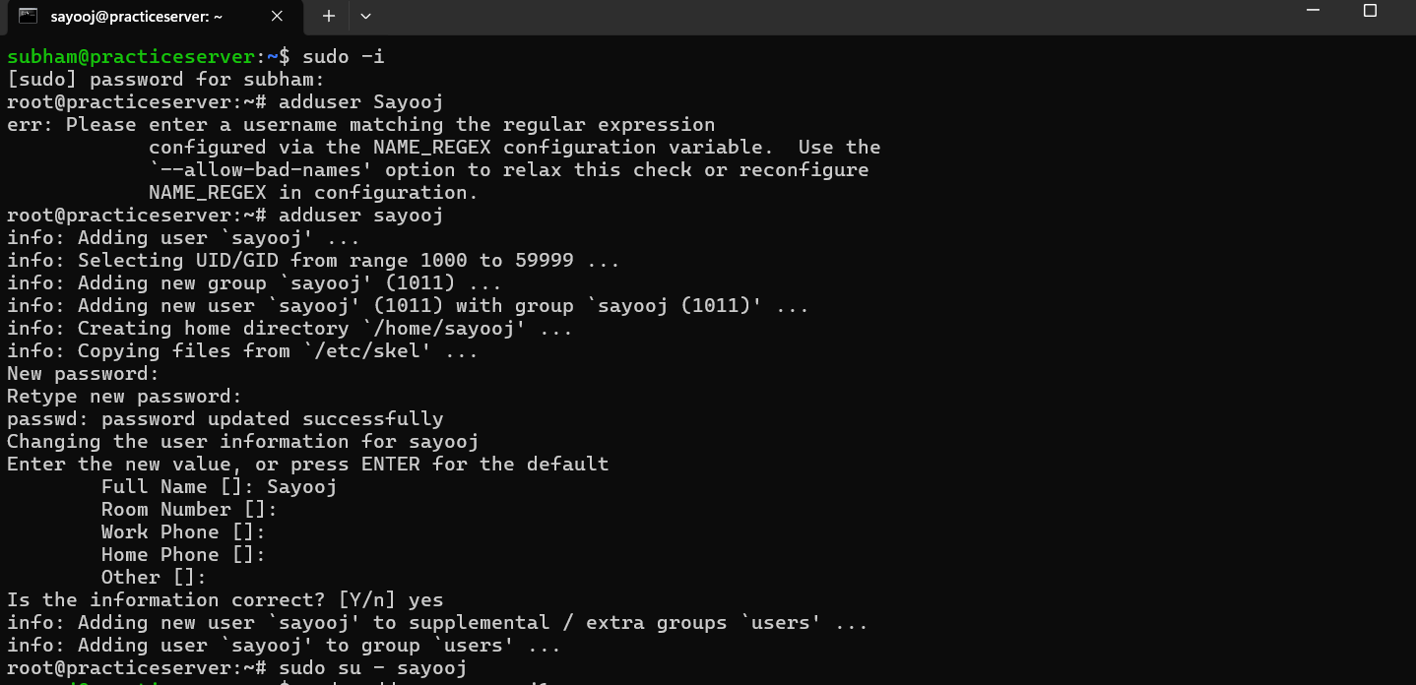

Create user :- In the above screen short we can see that I have created a user named Sayooj (Command used for it is adduser).
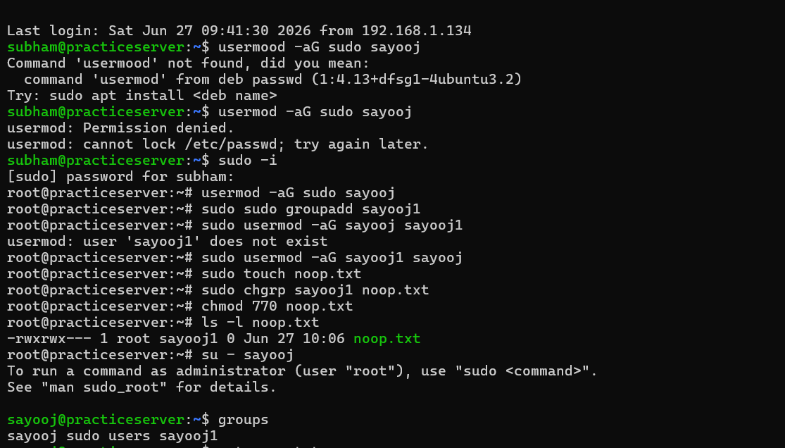

The screenshot demonstrates Linux user, group, and file permission management using terminal commands.
- Initially, the usermod command was entered incorrectly as usermood, resulting in a "command not found" error.
- Running usermod without root privileges produced a "Permission denied" error because modifying users requires administrative access.
- The user switched to the root account using sudo -i and successfully executed administrative commands.
- The user attempted to add sayooj1 to the sudo group, but an error occurred because the user did not exist.
- The correct user, sayooj, was then successfully added to the sudo group using:
Command :- usermod -aG sudo sayooj
- A file named noop.txt was created using the touch command.
Command :- sudo touch noop.txt
- The ownership of the file was changed to user sayooj1 with:
Command :- sudo chgrp sayooj1 noop.txt
- File permissions were modified to 770 using:
Command :- chmod 770 noop.txt
- For verify Access :
Command :- su - sayooj
Finally, after switching to the sayooj user, the groups command confirmed that the user belongs to the sudo, users, and sayooj1 groups, verifying successful group assignment.

